The site selection process is divided into, first is datacenter site selection, second is greenhouse site selection & third co-locating greenhouses and data centers. This is intended to develop a framework and briefing for the subsequent scope of work of this study.

### Datacenter Site Selection

##### Criteria for Site selection

Datacenters require careful navigation of intricate zoning laws, demanding permitting processes, and strict compliance standards across local, state, and federal levels. Some of the criteria focused on selecting the location for a new datacenters are listed below:

|  |  |  |  |
| --- | --- | --- | --- |
| **Criteria** | **Ideal Site** | **Worst Site** | **Real Site** |
| Power Availability | Favorable | Challenging | Favorable |
| Connectivity (Fiber Optics) | Favorable | Challenging | Favorable |
| Natural Cooling | Favorable | Challenging | Challenging |
| Water Availability | Favorable | Challenging | Favorable |
| Land Availability | Favorable | Challenging | Favorable |
| Labor Availability | Favorable | Challenging | In-between |
| Geopolitical Risk | Low | High/Moderate | Low/Moderate |
| Sustainability | Favorable | Emerging | Emerging |

##### Existing Datacenters

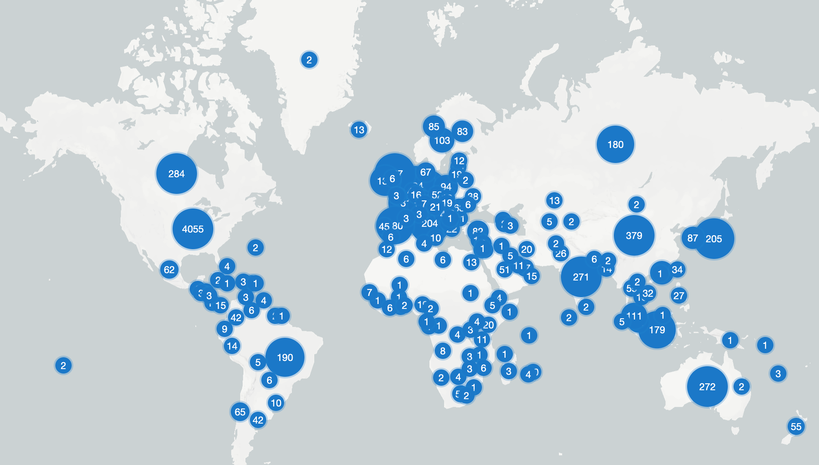

Source: www.datacentermap.com

The global distribution of data centers reveals a significant concentration in the USA, with 4,055 facilities, followed by the UK (487), Germany (483), and China (379). This pattern is a direct result of stringent site selection criteria, prioritizing regions with abundant, reliable, and affordable power—ideally from renewable sources. Other critical factors include dense fiber optic networks for low data latency, particularly near major internet hubs, and stable political and regulatory environments. Additionally, the high density in regions like Europe and China is heavily influenced by data sovereignty laws, such as GDPR, which mandate local data storage. This, combined with strong economic growth and large user bases, fuels the "Data Gravity" phenomenon, further concentrating digital infrastructure.

### Greenhouse Site Selection

##### Criteria for Site selection

Greenhouse site selection starts with defining the requirements clearly. While numerous variables influence greenhouse site selection, the primary focus should always be on maximizing production. Optimizing factors like sunlight access, water supply, and energy efficiency directly contributes to higher yields and profitability, especially for high-value crops. Not included within the scope are, an inventory of vertical farming, present (investment) policies of governments, private investment programmes, legal restrictions e.g. on water usage of lakes, restrictions on imports and exports (e.g. tomato from Morocco to EU), availability of local knowledge and expertise.

Some of the general criteria focused for greenhouse site selection include:

|  |  |  |  |
| --- | --- | --- | --- |
| **Criteria** | **Ideal Site** | **Worst Site** | **Real Site** |
| Land Availability | Favorable | Challenging | Favorable |
| Water Availability | Favorable | Challenging | Favorable |
| Surrounding Temperature | Favorable | Challenging | Favorable |
| Electricity & Natural Gas Availability & Price | Favorable | Challenging | Favorable |
| Market Accessibility | Easy | Challenging | In-between |
| Current Greenhouses | Abundant | Non existent | Present |
| Labor Availability | Favorable | Challenging | Favorable |
| Sustainability | Favorable | Emerging | Emerging |

The site selection of the greenhouse is also heavily linked with the type of vegetables, fruits & flower productions. Beyond temperature and humidity, the specific light requirements of various plants also play a crucial role. High-light crops might benefit from locations with abundant natural sunlight and a greenhouse structure optimized for maximum light transmission, potentially incorporating supplemental lighting during darker months. In contrast, shade-tolerant crops allow for more flexibility in site orientation or the use of shading materials. Furthermore, the growth habit and space requirements of different produce dictate the internal layout and even the overall scale of the greenhouse. Vine crops, for example, often require trellising systems and significant vertical space, while compact herbs can be grown in multi-tiered vertical farming setups, influencing the internal structure and potential automation. The chosen crop also impacts the necessary irrigation systems, nutrient delivery methods (e.g., hydroponics, aquaponics, or traditional soil-based cultivation), and pest and disease management strategies, all of which must be considered during site planning.

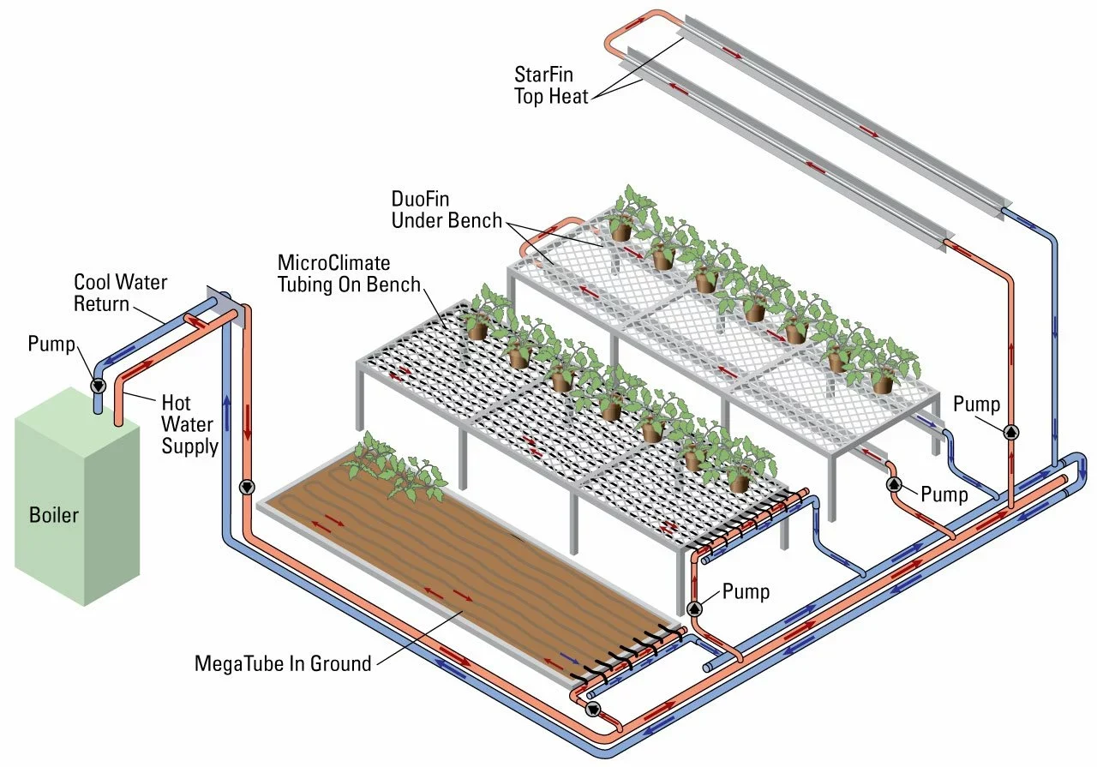

Source: https://biothermsolutions.com/

*In Greenhouse, heated water is strategically distributed through a network of pipes to three distinct zones: overhead "StarFin Top Heat" for general ambient air warming, "DuoFin Under Bench" and "MicroClimate Tubing On Bench" for efficient root zone heating directly beneath and on the grow benches, and "MegaTube In Ground" for warming the soil and providing foundational heat. After transferring its energy, the cooled water returns to the boiler for reheating, forming a continuous and efficient closed-loop system designed for precise climate control and optimal plant growth.*

*Effective greenhouse crop cultivation necessitates precise temperature and humidity regulation. The optimal temperature range for a greenhouse is between 17.7º C and 23.8 ºC, varying with the specific crop. Concurrently, it is crucial to maintain an optimal relative humidity level of approximately 80% (65-75% at night & 80% at daytime), as it is directly influenced by temperature. [*[*Source*](https://atlas-scientific.com/blog/ideal-greenhouse-temperature-and-humidity/?srsltid=AfmBOop0fCu1u08yAIU0Q4FfNU0TV5qQUTje2ldgvlWEBtKnfvRgwr-R)*]*

Key Terminology:

The **Daily Light Integral (DLI)** quantifies the total photosynthetically active radiation (PAR) that plants receive over 24 hours. It combines light intensity and photoperiod and is typically measured in moles of photons per square meter per day [mol/m²/day].

Optimal vegetable **temperatures** vary by variety and environmental factors like humidity and soil moisture. Therefore, understanding specific plant needs is crucial for productivity.

**Relative humidity (RH)** and **Vapor Pressure Deficit (VPD)** are two interconnected factors that influence vegetation growth. VPD is a measure of the drying potential of the air, uniquely independent of temperature and relative humidity. It quantifies the difference between the actual vapor pressure in the air and the maximum vapor pressure the air could hold at saturation. A smaller VPD indicates higher moisture content in the air, while a larger VPD signifies drier conditions. [[Source](https://ceresgs.com/an-introduction-to-vapor-pressure-deficit/)]

High RH (low VPD) can hinder transpiration, potentially slowing nutrient uptake (e.g., calcium) and increasing susceptibility to fungal diseases. Conversely, low RH (high VPD) can accelerate transpiration, leading to rapid wilting and plant stress if water absorption cannot keep pace. **VPD** is preferred over **RH** to assess how dry the air is at a given moment for environmental control because it better describes the driving force for plant transpiration by accounting for both temperature and humidity.

Additional **CO2 concentration** is often used in controlled environments to enhance photosynthesis and growth, especially when light (DLI) and temperature are optimal. The range of **800−1000 ppm** is commonly targeted, as the typical ambient atmospheric concentration is around 420 ppm. Concentrations above 1500 ppm are generally not beneficial and may hinder growth. This is critical to understand when considering removal or reduction of use of boilers and fossil fuel or biomass heaters which provide affordable sources of CO2 fertilization.

##### High-valued vegetables

Based on 2022 data, the estimated combined annual greenhouse production of tomatoes, cucumbers, peppers, lettuce, and strawberries in tonnes per hectare for seven nations are shown below. The chart highlights Canada (374 t/ha) and the Netherlands (355 t/ha) as the dominant leaders, whose yields are more than double those of mid-range producers like Mexico (154 t/ha) and Turkey (130 t/ha), and significantly higher than France (105 t/ha), Spain (81 t/ha), and Italy (52 t/ha); this vast disparity is attributed to the highly advanced, capital-intensive controlled environment agriculture (CEA) technology, including hydroponics and supplemental lighting, employed by the top-ranked countries.

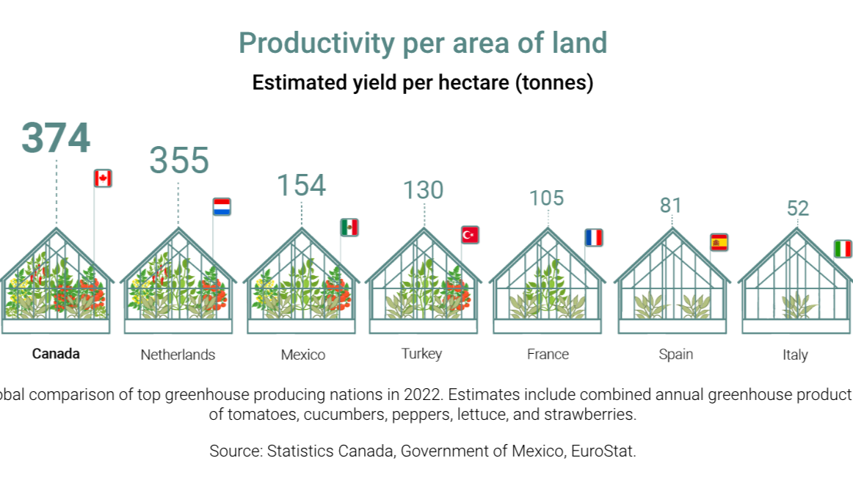

Source: RBC Climate Action Institute

High-value greenhouse vegetables demand precise environmental control to maximize both yield and quality, with each crop requiring specific combinations of temperature, light, humidity, and atmospheric conditions to achieve optimal photosynthesis and growth.

|  |  |  |
| --- | --- | --- |
| Variable | Details | Source |
| Cucumber | | |
| DLI | 20 to 35 mol/m²/day or even higher for best quality/yield | <https://heliospectra.com/blog/greenhouse-cucumbers-high-light-vegetable-series/> |
| Optimal temperature | Daytime: 20-22ºC  Night time: 19-20ºC | <https://www.haifa-group.com/cucumber-fertilizer/crop-guide-growing-cucumbers> |
| Vegetative growth and fruit setting: 21-26°C  Seed germination: 15-29°C | <https://drygair.com/blog/cucumber-greenhouse/> |
| Tomato | | |
| DLI | 20 to 40 mol/m²/day | <https://www.horti-growlight.com/en-gb/typical-ppfd-dli-values-per-crop> |
| Optimal temperature | Recommended: 20-29ºC  Can’t tolerate temperature <13ºC & >35ºC . | <https://www.deep-roots-project.org/grow-your-own-food-all/veggie-temperature-tolerances#gsc.tab=0> |
| Sweet Pepper | | |
| DLI | Vegetative growth and fruit setting: 25 to 50 mol/m²/day  Seed germination: 12 to 16 mol/m²/day | <https://www.atophort.com/news/the-guide-to-increase-greenhouse-pepper-yield.html> |
| Optimal temperature | Daytime  Vegetative growth and fruit setting: 21-24°C  Seed germination: 26-28°C  Night time  Vegetative growth and fruit setting: 17-21°C  Seed germination: 26-28°C |
| Eggplant | | |
| DLI | 20 to 35 mol/m²/day | <https://growlightmeter.com/light-requirements-for-plants/> |
| Optimal temperature | Daytime  Vegetative growth and fruit setting: 21°C - 26°C  Seed germination: 19-22°C  Night time  Vegetative growth and fruit setting: 16-21°C  Seed germination: 16-19°C | <https://www.atophort.com/news/how-to-grow-eggplants-in-greenhouses.html> |

##### Existing Greenhouses

The commercial greenhouse industry worldwide is experiencing rapid growth and specialization. This acceleration is a direct result of the converging needs for food security, climate change adaptation, and environmentally responsible production methods.

Breakdown of the greenhouse categories in terms of technology & investment required:

|  |  |  |
| --- | --- | --- |
| Technology | Climate Control Level | Estimated Investment (€/m²) |
| Low-Tech | Passive/Limited | < 30 |
| Mid-Tech | Semiactive | 30 to 60 |
| High-Tech | Active/Fully Controlled | > 60 (up to 500) |
| Vertical Farm | Fully Control + Cooling | > 1000 to 1800 (up to 2000) |

* Low-tech (Passive technology): These structures typically have low production, are not used year-round, and have no automation. They are sensitive to the environment and climate and are often covered with plastic mesh.   
  **No use for DC Heat Reuse.**
* Mid-tech (Semiactive technology): These structures incorporate semiautomated systems for things like heating, ventilation, irrigation, and cooling. Crops can be grown in soil or growing media (substrates). These structures are often plastic tunnels with dividers for different crops.  
  **Low use for DC Heat Reuse.**
* High-tech (Active technology): These structures feature a fully automated and controlled environment. They can precisely manage irrigation, nutrients, temperature, humidity, and even solar radiation. Crops can be grown in soil, growing media, or hydroponic systems. The structures are typically tall and made from glass or double-paneled plastic.  
  **High use of DC Heat Reuse.**
* Vertical Farms (Active Cooling needs): These systems of food production utilize warehouses, shipping containers, and large enclosed buildings without sunlight. They are the most extreme Controlled Environments and require active heat rejection due to the intensity of the cooling needs for the LED lights which can operate for 16 hours per day. There are liquid cooling systems for lights and facilities which can provide heat into thermal energy networks but will not be likely to utilize rejected heat from datacenters.  
  **No/low Use of DC Heat Reuse.**

Greenhouses represent a significant leap in agricultural innovation, allowing for controlled environment agriculture (CEA). These enclosed structures empower growers to precisely manage factors like lighting, temperature, humidity, and nutrient delivery, optimizing plant growth and resource efficiency. From small solutions like simple hoop houses to advanced, fully automated Venlo-style greenhouses, the variety of structures caters to diverse scales and needs.

Basic structure architectures are shown below:

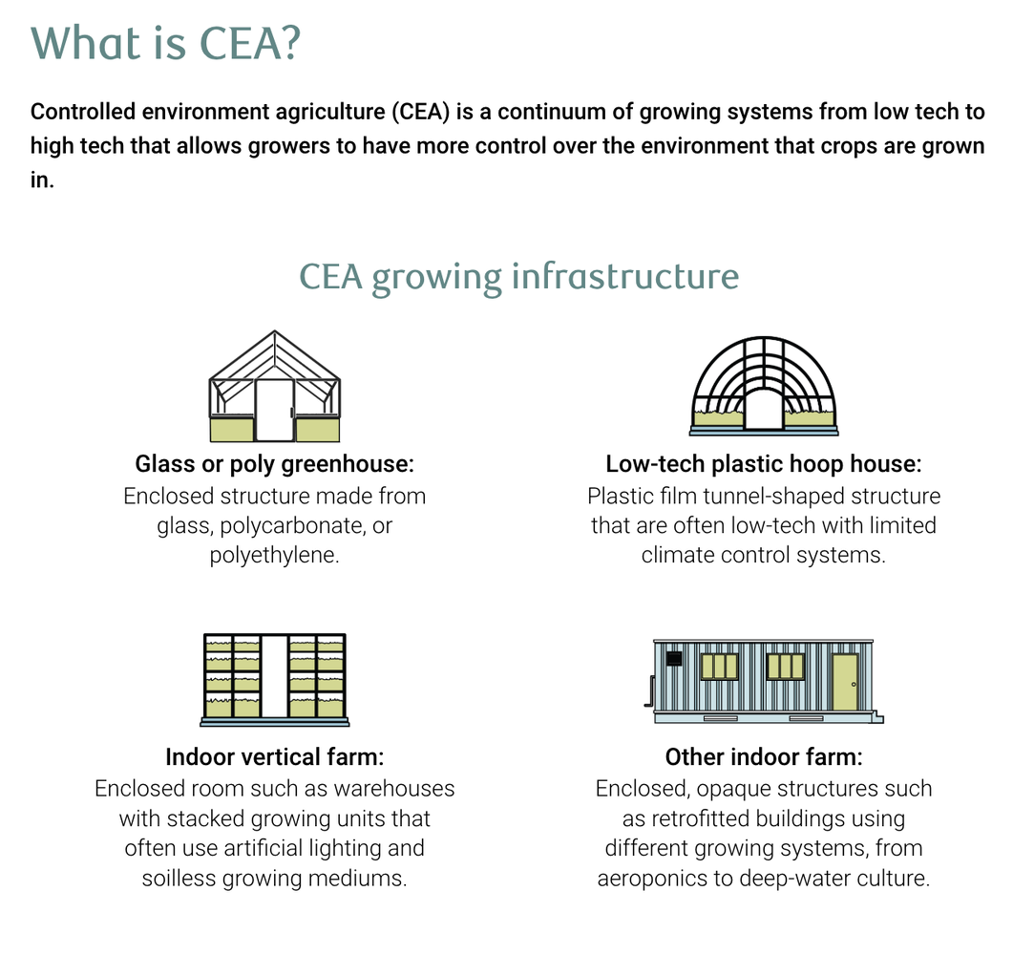

Source: RBC Climate Action Institute

The global greenhouse area is currently estimated at approximately 3.72 million hectares. The vast majority of this acreage falls within the low- or mid-tech categories (3.65 million hectares), suggesting that most global production remains vulnerable to climate variability and seasonal dependence. Only 70,000 hectares worldwide are categorized as high-tech, underscoring the substantial global opportunity for modernization.

High-tech greenhouse cultivation is most prominent in Europe, particularly in countries with cooler or temperate climates, accounting for approximately half of the world's highly automated facilities. A similar pattern is observed in North America, where high-tech facilities are concentrated in colder regions like Canada and the northern US. Conversely, low- and mid-tech greenhouses are more common in the Mediterranean region, as well as the southern US and Mexico. Beyond these primary regions, high-tech greenhouses are also established in certain Asian countries (including the Persian Gulf, Kazakhstan, South Korea, Japan, and China) and Oceania (Australia and New Zealand).

The choice of greenhouse technologies is determined by the specific crop requirements, market demands, and prevailing growing conditions. Tomatoes are the leading crop in global greenhouse cultivation, accounting for approximately 36% of the total area. This crop also stands out in the adoption of advanced technology, with 50% of tomato cultivation occurring in high-tech greenhouses. Other crops, including cucumbers, peppers, and eggplants are more evenly distributed across low-, mid-, and high-tech structures. [[Source](https://topsectortu.nl/wp-content/uploads/2025/03/RaboResearch_Global-greenhouse-update_2025.pdf)]

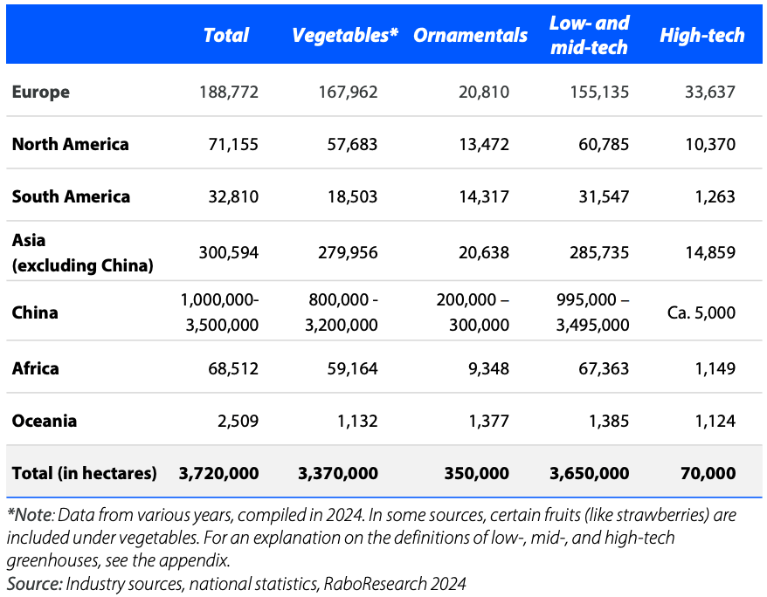

Source: Industry sources, national statistics, RaboResearch 2024

### Advanced Thermal controls of Commercial Greenhouses:

The advanced commercial greenhouses existing today have sophisticated thermal management systems and are substantial in scale and operation. These are the ideal heat offtakers to pair together and co-locate with datacenters. The scale of single greenhouses reach 25-80 acres (upwards of 325,000m²) and generally cluster to thousands of acres of greenhouses in a region.

As an example: A single 25 acre high tech Venlo Style greenhouse which is 25 acres in Ontario Canada growing Peppers without LED light supplementation has 4 Combined Heat and power generators of 3.3MWe+3.1MWth each (13.2MWe + 12.4MWth) and an additional 5 hot water boilers of 8.8MWth each (44MWth) to support the facilities heating needs. They will have a storage buffer tank with a capacity of 6000m3 to store this heat which is about 500MWh of thermal storage. This manages the thermal balance and capacity required to heat and maintain ideal temperatures in the greenhouses.

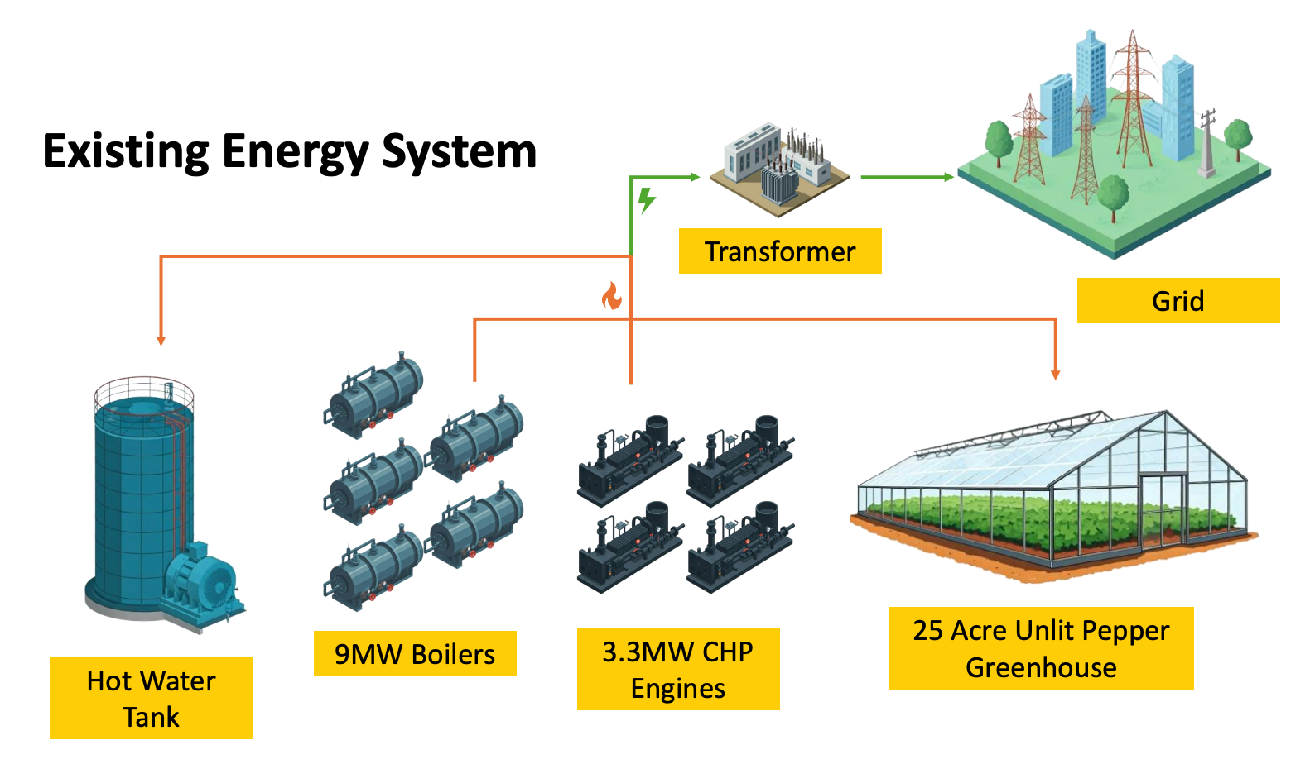

Source: Anup J Poudel, Canadian Greenhouse Conference, Research Poster

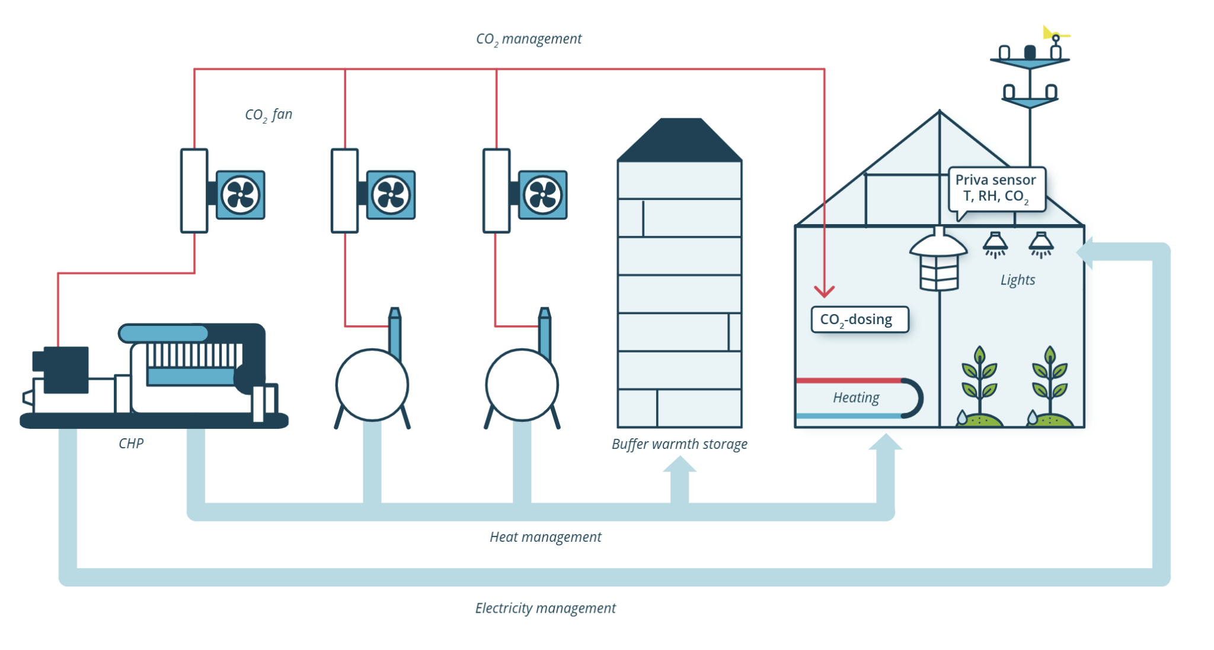

Source: https://www.priva.com/media/wztpbmio/en-brochure-connext-12pg-defonline-202205.pdf

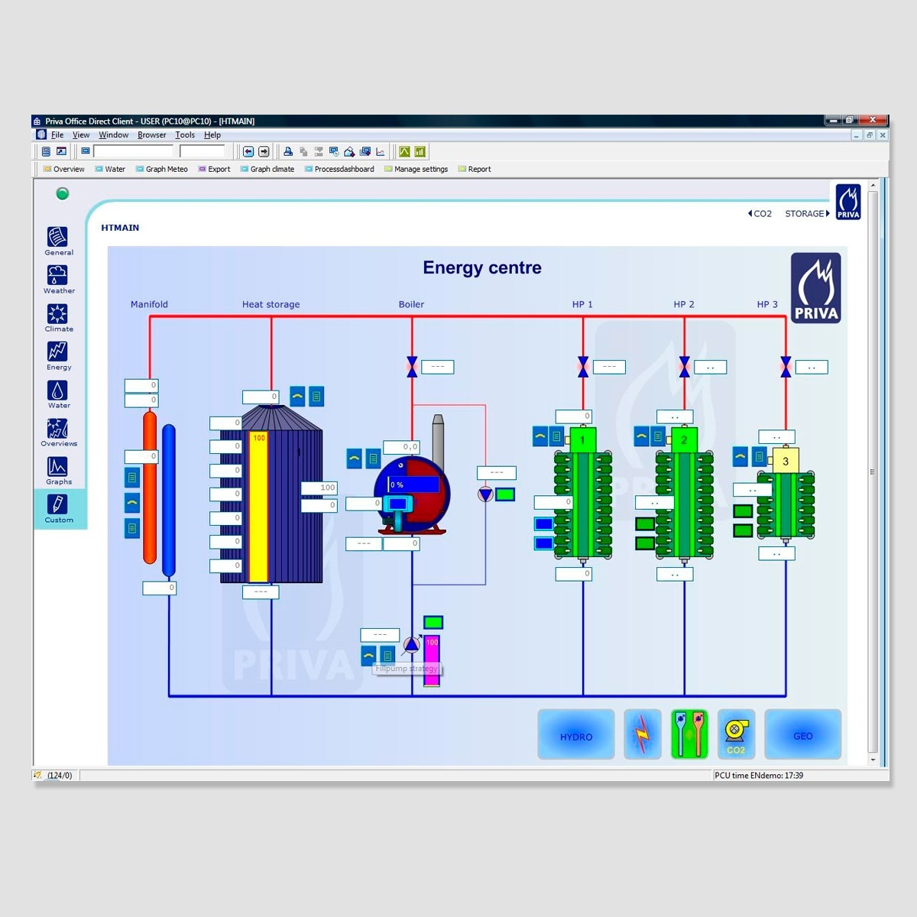

### Advanced Management Software:

Software to manage the overall facilities and energy system of the greenhouse are managed with precise controls for the thermal and electrical production requirements of the systems, which operate separately but interconnected to the set points and environmental controls of the crop section of the greenhouse which are managed by an entire other system and master growers. The intricate linkage and the economic decisions of the greenhouse are decided by thermal management teams at the greenhouse, while the temperature needs and demands are determined by the growers. These roles are critical to maintaining the sophisticated economic decisions of the minimization of the operating costs of the greenhouse operation and the optimization of yield and crop quality to maximize revenue generation of the facilities.

Deeper evaluation and modeling of these setpoints, thermal demands as this shifts and changes through the seasons, locations and crops will be part of the scope of the further study and modeling.

### Co-location Site Selection

The co-location site selection process prioritized criteria for integrating a datacenter and greenhouse. This strategic pairing allows for the efficient utilization of waste heat generated by the datacenter to provide heating for the greenhouse.

##### Criteria for Site selection

There are three potential options: either a complete new build integrating both a data center and a greenhouse, or the strategic placement of a new greenhouse adjacent to an existing data center, or vice versa.

The site selection process becomes more intricate, requiring a multi-faceted evaluation. Initially, both the data center and the greenhouse must undergo independent site selection based on their respective, unique criteria. For instance, data centers typically require reliable power grids, fiber optic connectivity, accessibility for maintenance, and considerations for security and disaster recovery. Greenhouses, on the other hand, necessitate optimal solar exposure, access to water resources, suitable soil conditions (if applicable to the growing method), and proximity to markets or distribution channels.

After confirming the viability of individual sites, the next step involves evaluating the technological aspects of connecting data centers and greenhouses for waste heat recovery. This colocation framework is heavily influenced by the temporal patterns of waste heat generation and demand—specifically, daily, hourly, and seasonal cycles. Data centers consistently produce low-grade heat, making it possible to efficiently capture and redistribute this heat to meet the base load of varying thermal needs of a greenhouse.

Key factors to assess include:

* Proximity: The distance between the proposed data center and greenhouse.
* Topography: The land's features that might affect installation.
* Heat Transfer Mechanisms: The ease of installing robust systems like pipes, heat exchanger & heat pump.
* Energy Loss: The potential for heat loss during transmission.
* Financial and Climate Impacts: Determine shared benefits and quantify savings.

The design must also consider the specific heat rejection requirements of the data center and the heat demand profiles of the greenhouse. This ensures a synergistic relationship where waste heat is efficiently captured, transported, and used for climate control or other processes within the greenhouse. The ultimate goal is to maximize energy efficiency and minimize operational costs for both facilities.

##### Primary Barriers for Co-locations

Colocation, while offering potential benefits, faces several challenges that require strategic solutions:

* High Infrastructure Costs: The need for additional pipes, heat exchangers, and connection systems leads to significant upfront capital expenditure. This barrier can be overcome with effective financing models and equitable cost-sharing agreements.
* Site Selection Limitations: Greenhouses typically prioritize proximity to markets and labor. Colocating with data centers or industrial facilities might necessitate less-than-ideal locations. Balancing the needs of both parties is crucial to resolving these site-related challenges.
* Operational Complexity: Managing shared resources such as heat, power, and maintenance across different industries presents a complex operational challenge. This can be streamlined through improved coordination and the implementation of smart management frameworks. The inconsistency of heating requirements of a greenhouse do not perfectly align with the heat production output from datacenters. This discrepancy can be mitigated by thermal storage systems, proper sizing of heat reuse to capacity factors and integration with other heat use assets alongside simply greenhouse temperature management.
* Alternative heat use assets: Greenhouses require substantial water, CO2, backup power, and cooling for cold storage. These assets can help to provide other heat use assets outside of the thermal needs of the greenhouses.
* Misaligned Timelines & Budgets: Different industries often have varying investment planning speeds. Aligning timelines or introducing flexible financing options can facilitate smoother partnerships.
* Backup System Requirements: Greenhouses cannot afford to lose heat or power, leading to continued investment in backup systems. Guaranteed reliability from the colocation partner can help reduce these additional costs. The same is true for datacenters which require power and cooling needs at all times. Backup power operations are present for both facilities offering potentially other synergies.
* Contractual Risks: Long-term sharing agreements are susceptible to failure if one partner alters their operations. Clear agreements and robust risk-sharing structures are essential for effective management. Proper SLA agreements must be maintained and developed for both parties as heat providers and cooling providers.
* Perception Issues: Consumers may have concerns about produce grown in close proximity to industrial sites. Proactive communication and educational initiatives can build trust and address these perception challenges.
* Labor & Market Access: Industrial sites may lack access to suitable agricultural labor or be situated far from target markets. Better planning and shared logistics can mitigate these barriers. Greenhouses directly employ over 2.5 per acre of greenhouse, plus ancillary service providers to support the sector.
* Limited Power Availability: Both datacenters and greenhouses require substantial quantities of power to operate these facilities. For datacenters operation of the servers, cooling, and facilities are critical limiting factors for development. For greenhouses, power is used for pumping, heating, lighting, air handling, and cooling or food storage. These can represent many tens of megawatts for the scale of large commercial production growing facilities. This creates competing factors for resources.
* Limited Water Availability: Datacenters require substantial cooling and water evaporation has been a key solution for maintaining optimal temperatures with evaporative cooling. Greenhouses use significant quantities of water to grow crops. While greenhouses use upwards of 90% less water than conventional agriculture due to their ability to reuse and cycle water and humidity, they nevertheless still consume significant amounts of water which the plants both transpire during the photosynthesis process and also in the body and fruit of the plants as well. The local water table, rainfall and availability of fresh water can be another major limiting factor of the scale of greenhouse production possible in a region or area.

If challenges like cost, site flexibility, operational complexity, reliability, contracts, perception, and labor access are solved, greenhouse–data center colocation can become fully viable—unlocking strong economic value and major environmental benefits.

##### Ideal for Co-locations

Given the higher number of greenhouses compared to data centers, it's crucial to assess a location's feasibility for data centers for which data center cooling is a significant constraint. Data centers utilizing free natural cooling or requiring advanced mechanical cooling are often in locations unsuitable for greenhouses, as it might need more heating or evening cooling and extensive ventilation. Therefore, data centers employing high-efficiency mechanical cooling and adiabatic cooling as shown below in the figures are ideal for co-location with greenhouses, as these locations can offer a more consistent heating demand for greenhouses.



Source: Azure Modern Datacenter Cooling Infographic

The accompanying figure visually reinforces the strategic alignment between high-efficiency and adiabatic cooling methodologies for data centers and the potential locations for mid-tech and high-tech greenhouses. The red circle in the illustration specifically demarcates areas where these advanced cooling techniques are most effectively deployed for data center operations. Notably, these same regions exhibit a strong correlation with ideal conditions for the establishment of both mid-tech and high-tech greenhouses. This overlap is not coincidental; the principles driving efficient cooling for data centers often involve factors such as access to cooler ambient air, proximity to water sources for adiabatic cooling, or areas with specific microclimates that lend themselves to reduced energy consumption. These same environmental attributes can be highly beneficial for greenhouse operations, which often require precise temperature and humidity control. Therefore, this spatial congruence, clearly highlighted in the figure, provides compelling evidence and strong support for the proposed location ideas, suggesting a potential for synergistic development where the waste heat from data centers be utilized to warm adjacent greenhouses, creating a more sustainable and resource-efficient ecosystem.

Below are two global models outlining the Potential mapping across the earth for Mid Tech and High Tech greenhouse locations. Followed by an example of Germany on a regional basis of where these ideal sites for high tech greenhouses could be developed. Overlaying the both existing datacenter locations and ideal datacenter locations in Germany and other sites around the world will provide insight and opportunities for ideal collations.

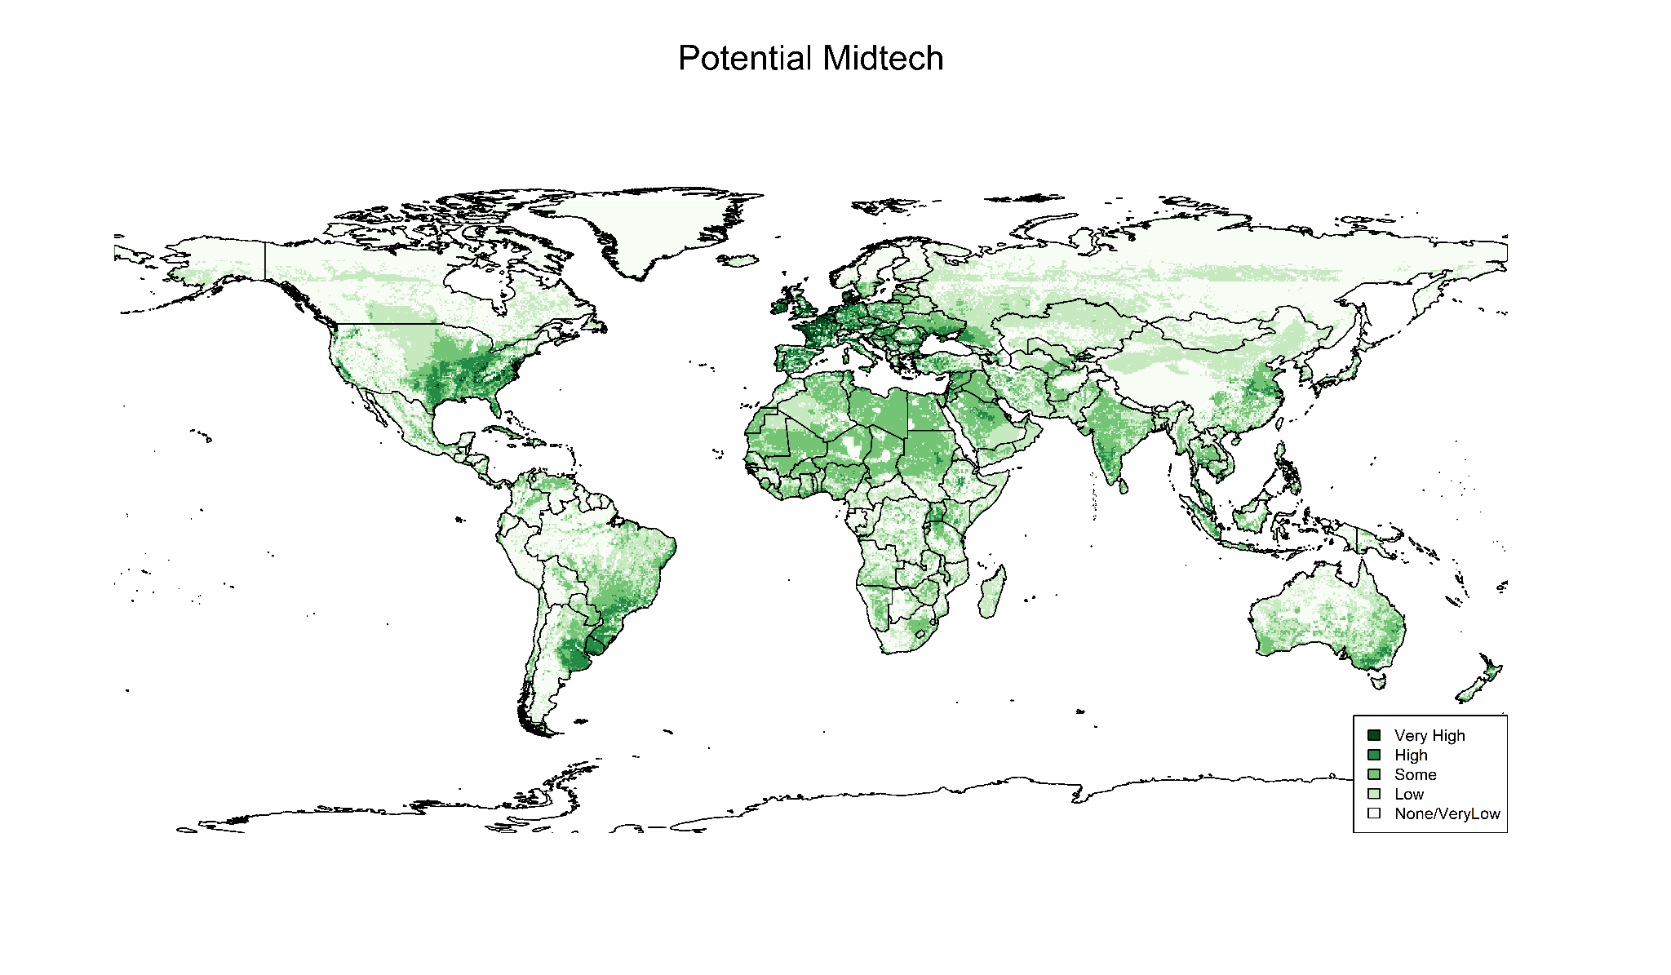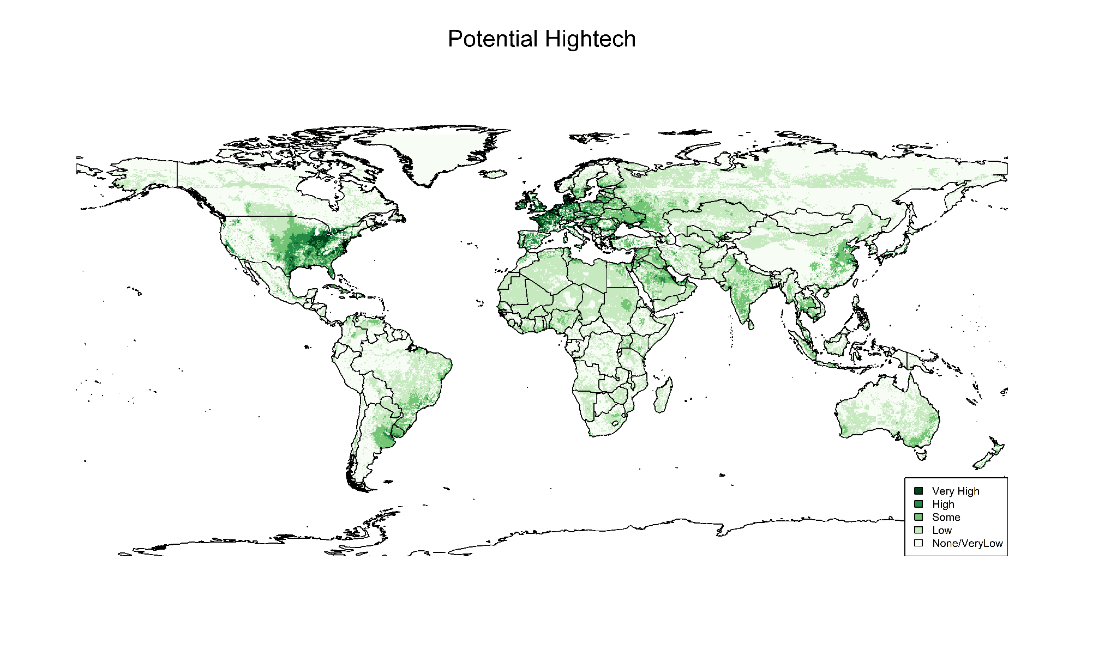

##### Ideal for Co-locations: Germany Hightech Greenhouses

##### 

### 

### Priority Country Selection

The process of selecting co-location sites must consider the significant impact of policy decisions made by countries and regions on data centers. For instance, Germany mandates the sharing of heat with other assets, while other regions require feasibility studies to assess opportunities. These countries should be prioritized when evaluating greenhouse development potential and existing facilities.

EMEA countries, particularly Germany, Sweden, Denmark, the UK, Spain, and the Netherlands, are key areas of focus.

The European Union has a strong initiative to reduce natural gas imports from Russia. This effort necessitates substantial improvements in efficiency and a decrease in natural gas consumption across various industries. The greenhouse sector, a major consumer of natural gas for heating and CO2 dosing, should be a primary focus in both policy development and the economic viability of individual greenhouses. European investors are also increasingly likely to finance sustainable agriculture, local food production, and environmentally friendly projects. The availability of capital for these high-cost projects will alleviate financing challenges for new controlled environment agriculture facilities, thermal energy networks, and sustainable data centers. Given these market conditions and the scale of the opportunity, Europe is a crucial area for demonstrating the scalability and viability of co-locating data centers and greenhouse facilities, along with thermal energy networks and supporting technologies such as carbon capture, industrial dehumidification, water desalination, and waste utilization through anaerobic digestion, absorption coolers, and cold storage facilities. This report will prioritize highlighting specific areas ideal for highly scalable, high-technology greenhouse production capacity and market prioritization.

### Priority Site Selection & Detailed analysis

This research aims to strengthen Microsoft's negotiation position with heat off-takers, particularly greenhouses, and foster better integration of data center facilities with communities. A detailed analysis is crucial for identifying ideal crop types, greenhouse structures, deployment locations, and colocation benefits. By examining specific site opportunities, we can demonstrate the economic, environmental, and community advantages of heat reuse in Microsoft's current and future operating communities.

Our report will provide a highly detailed analysis for a greenhouse scaled to an existing Microsoft data center, including an expansion plan for a larger facility at a specific site. This will lay the groundwork for subsequent feasibility studies at other Microsoft data center locations. A deep analysis at this site will enable more effective negotiations with heat off-takers, accounting for system costs, thermal energy network expenses, heat pump requirements, and overall ecosystem compensation among all parties.

**Netherlands: Middenmeer**

Approximately 5 km² of greenhouses are directly adjacent to the data center in Middenmeer. Preliminary estimates suggest a heating requirement of 110-150 Watts per m² for greenhouses in the Netherlands. This could necessitate 625 MW - 750 MW of heat on the coldest day of the year for several hours.

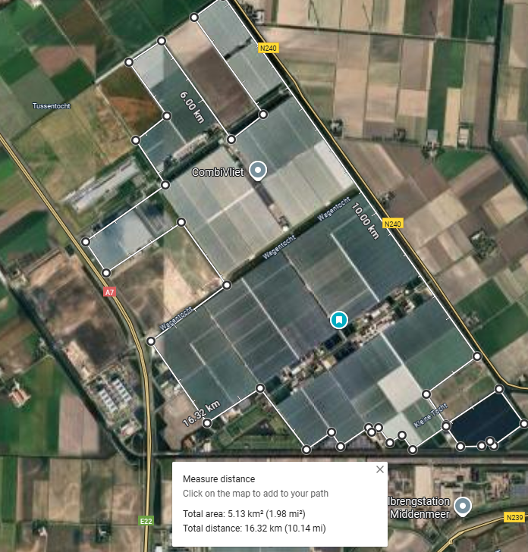

Modeling will be conducted to develop clear thermal requirements for greenhouses and usable temperature and kWh requirements.

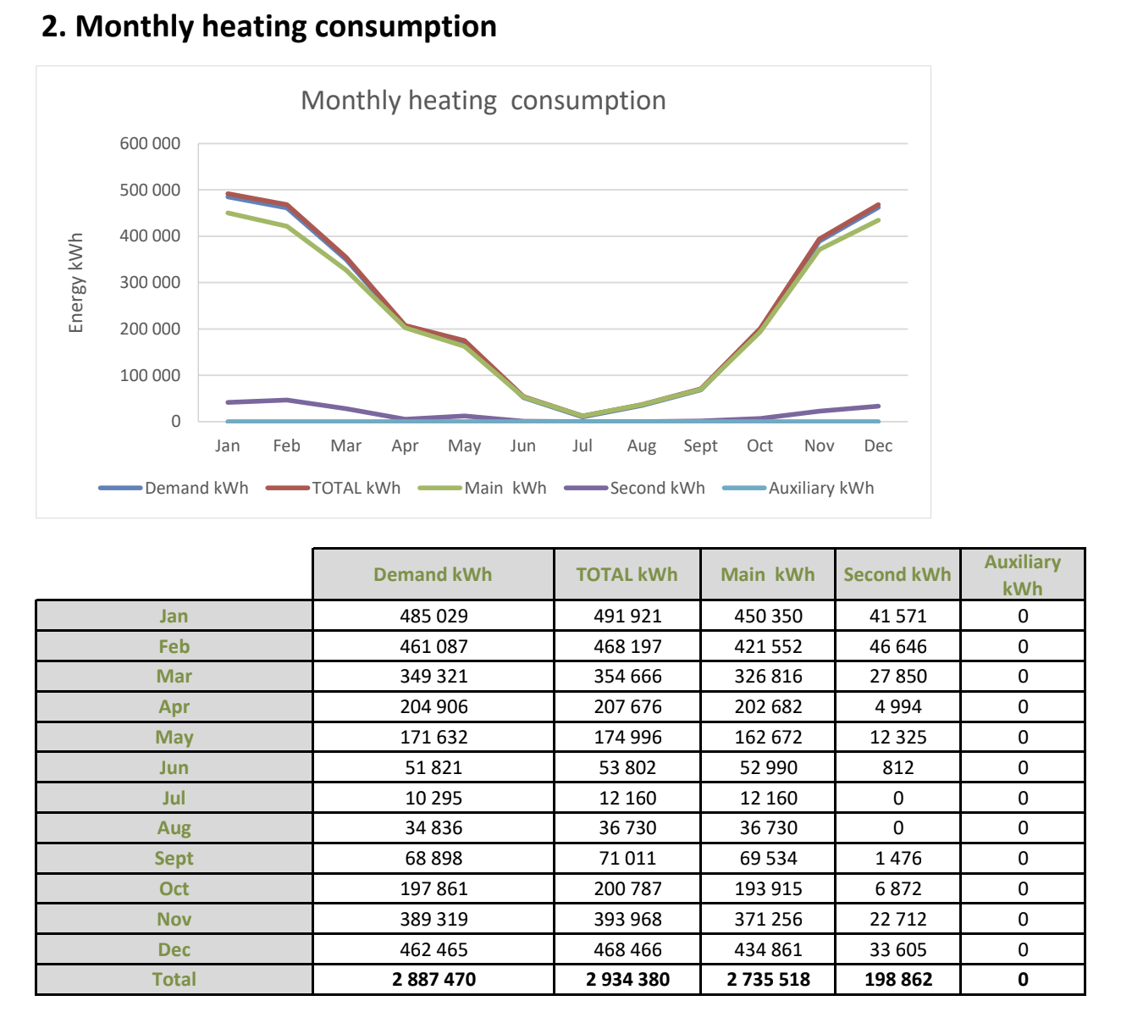

Additional evaluations will be conducted on alternative sites with questionable proximity and use cases to evaluate or calculate if there is an economic use case for a heat reuse application as it relates to the proximity to the datacenter and also towards improvement of food security to the local area.

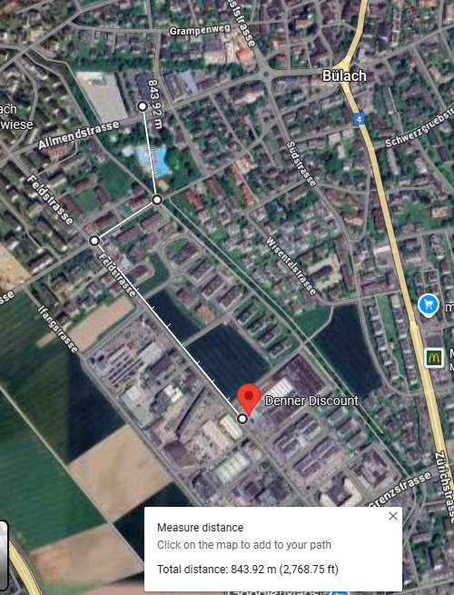

Equinix ZH5   
Zurich   
Allmendstrasse 13,   
Bulach, Switzerland

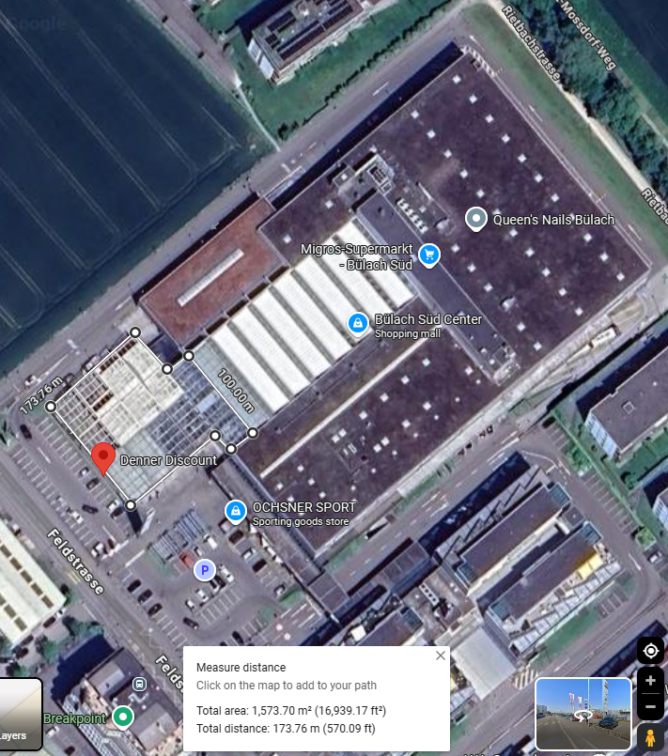

1570m2  Greenhouse adjacent to a grocery store